CSC108 – Introduction to Programming

Lab05A:

**Convert Decimal to Binary:**

Create a Java application in NetBeans called “Lab05A” that converts a decimal integer between 0 and 255 to binary. You must show all eight binary digits. You can use integer division by 2 and modulus 2 to obtain each of the eight bit positions (see algorithm below). Any integers outside that range should be rejected, and the program should ask the user to re-enter the integer. This process should continue looping until the end user enters 999, at which time the program displays “Program ending.” and ends.

**Algorithm:**

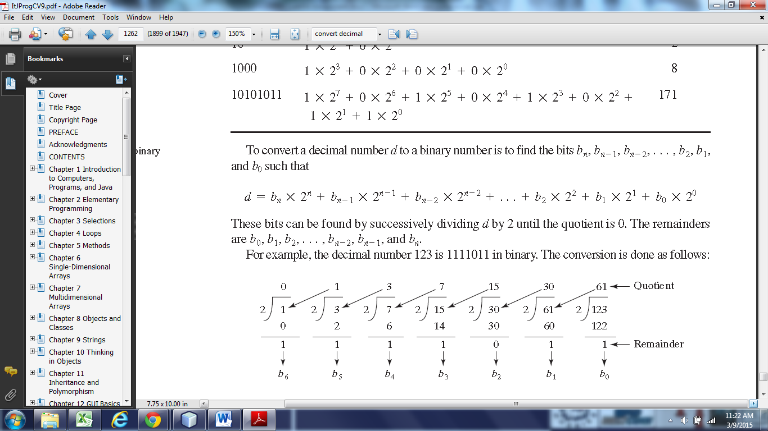

Sample Java output:

run:

Enter an integer between 0-255, or 999 to exit: 256

Entry out of bounds. Please re-enter: -1

Entry out of bounds. Please re-enter: 255

Decimal= 255

Binary= 11111111

Enter an integer between 0-255, or 999 to exit: 1

Decimal= 1

Binary= 00000001

Enter an integer between 0-255, or 999 to exit: 999

Program ending.

Zip the Lab05A folder and send it to me as an attachment in Blackboard.

Flowchart: 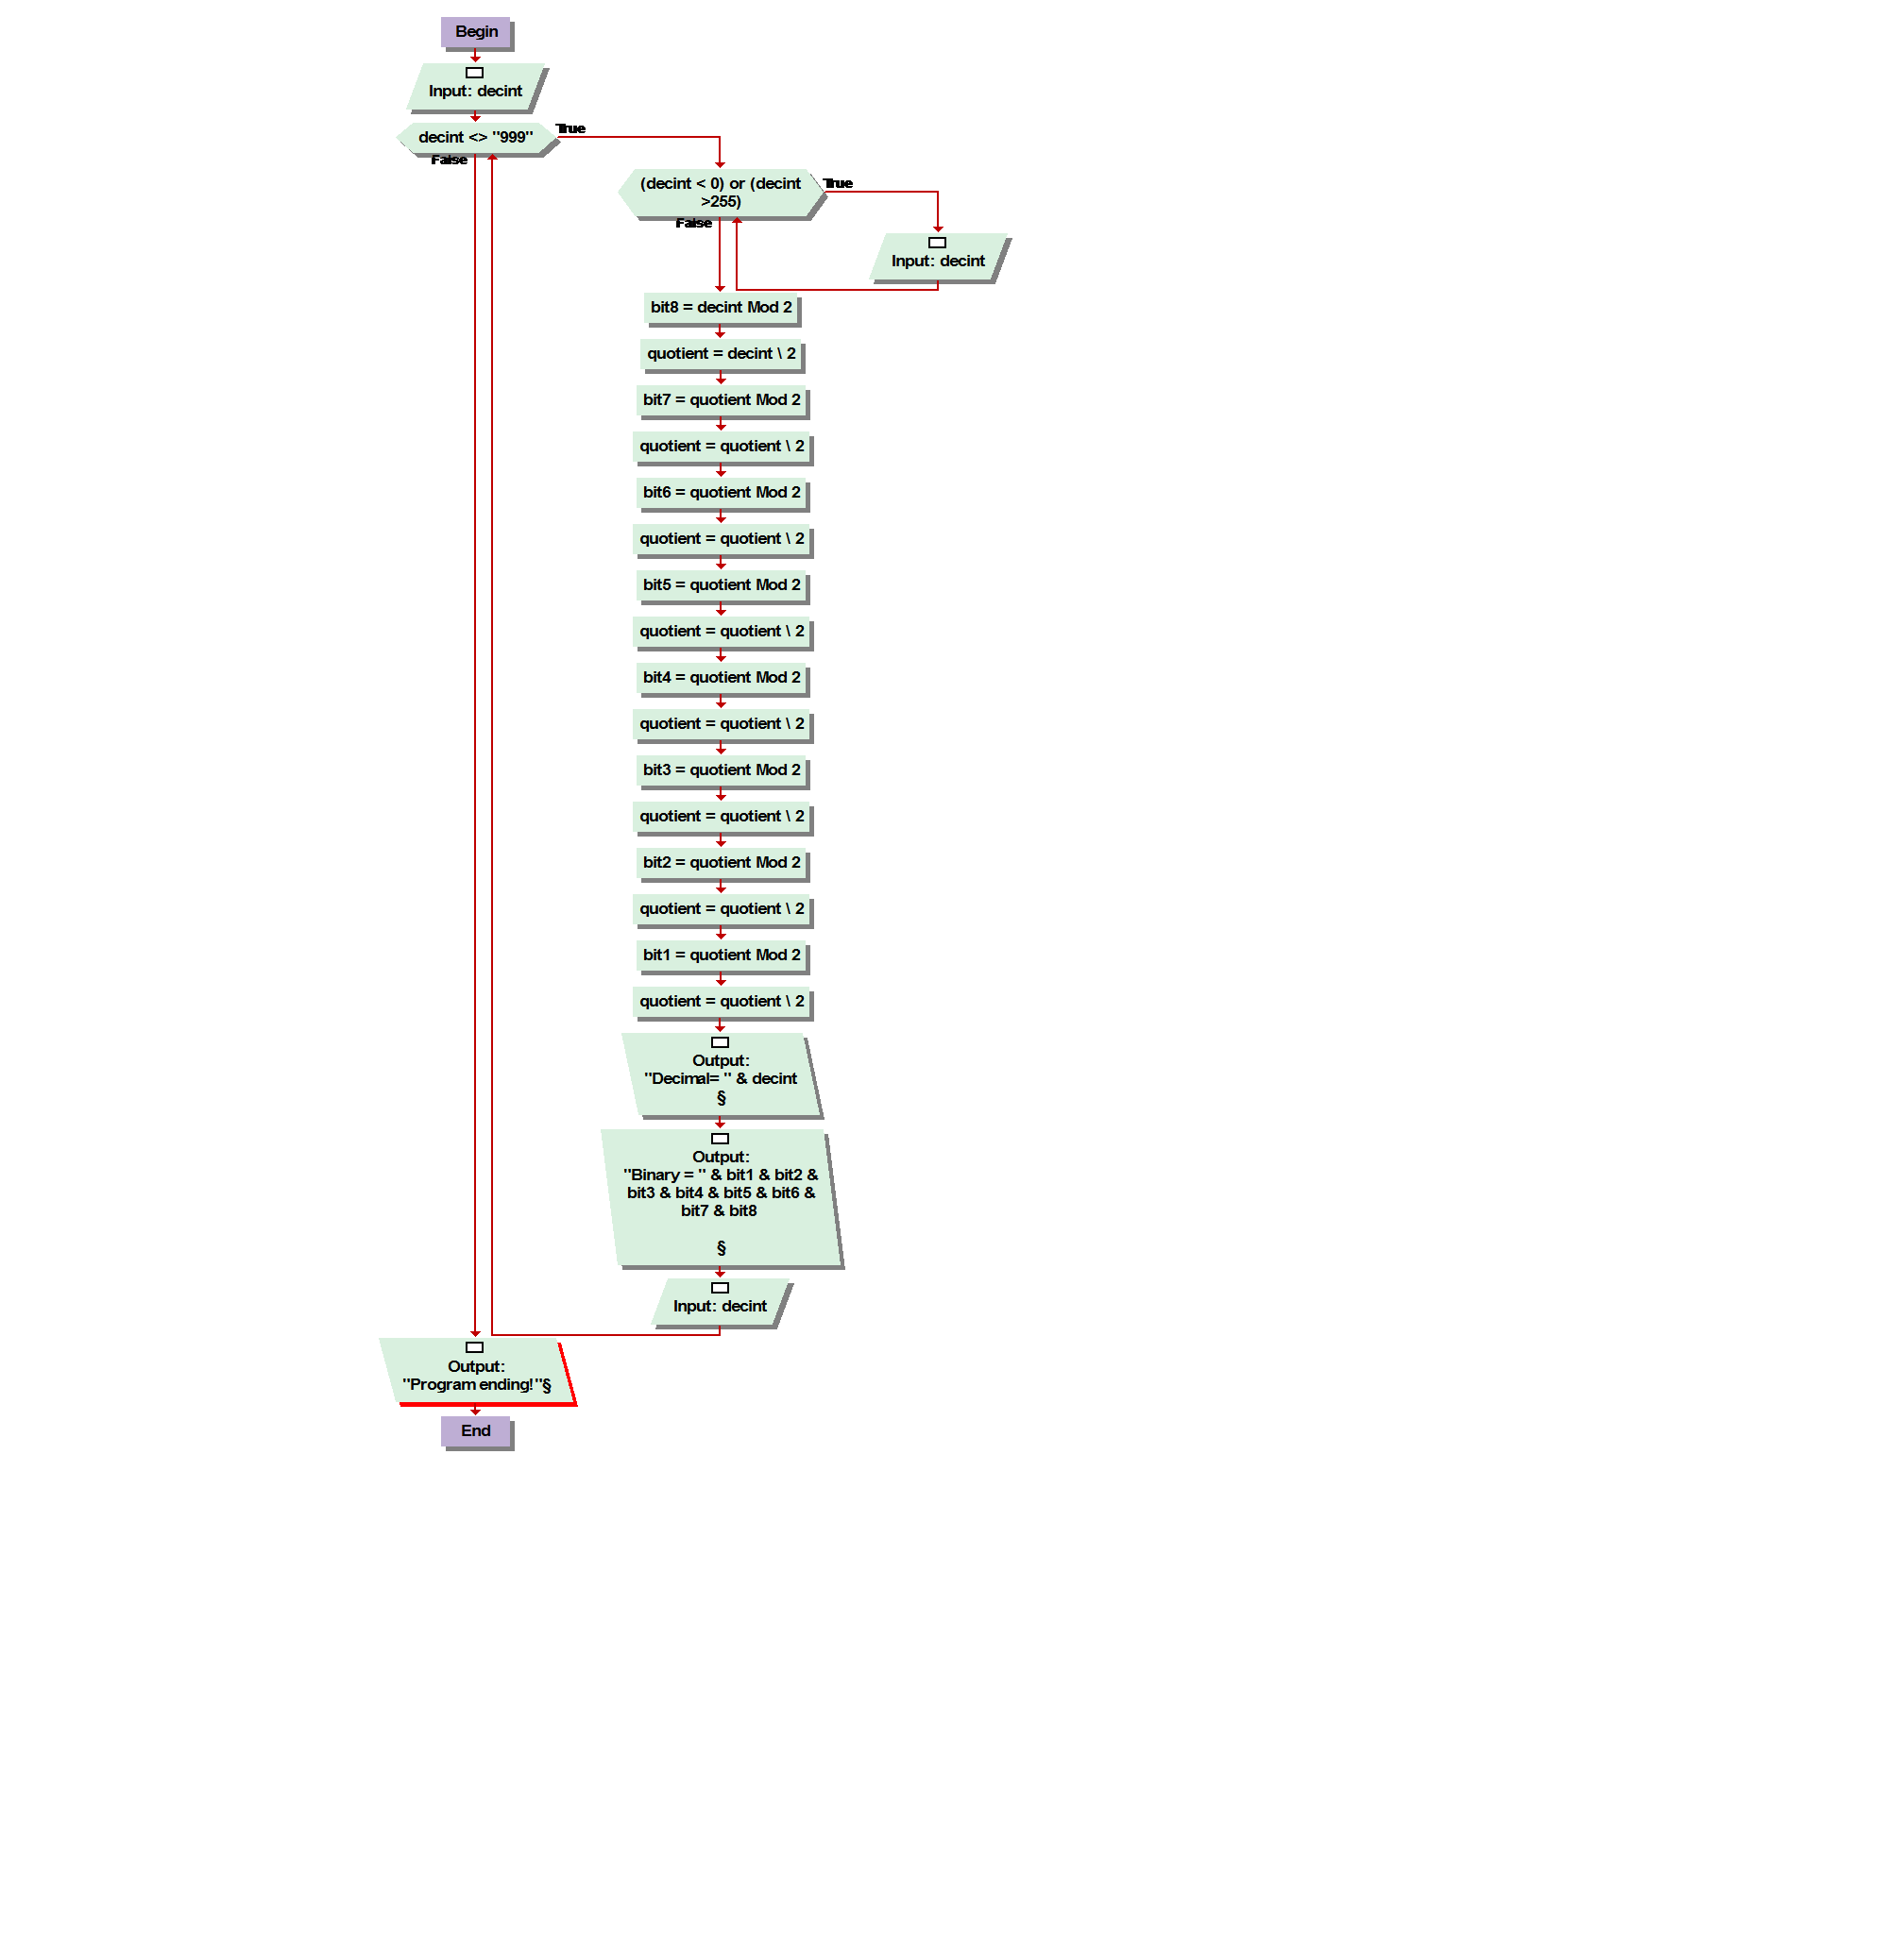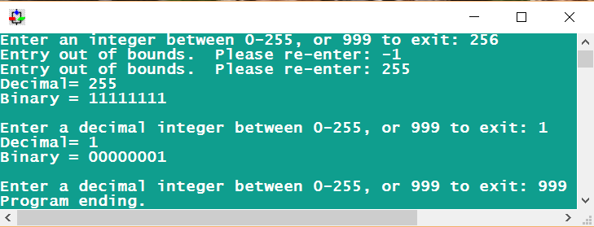

Answer programming

package lab05aWaiyat;

import java.util.Scanner;

public class lab05aWaiyat {

public static void main(String[] args) {

Scanner in = new Scanner(System.in);

//input decint,bit and quotient

Int decInt , bit8,bit7,bit6,bit5,bit4,bit3,bit2,bit1;

Double quotient;

System.out.print(“Enter an integer between 0-255, or 999 to exit:”);

decInt=input.nextInt();

//while is not 999

while(decInt !=999) {

while(decInt < 0 || decInt > 255){

System.out.println(“Entry out of bounds. Please re-enter:”);

System.out.println(“Enter an integer between 0-255, or 999 to exit:”)

decInt = input.nextInt();

}

// Bit and quotient

bit8= decInt %2;

quotient = (double) decInt/2;

bit7 = (int) quotient %2;

quotient = quotient %2;

bit6 = (int) quotient %2;

quotient = quotient %2;

bit5 = (int) quotient %2;

quotient = quotient %2;

bit4 = (int) quotient %2;

quotient = quotient %2;

bit3 = (int) quotient %2;

quotient = quotient %2;

bit2 = (int) quotient %2;

quotient = quotient %2;

bit1 = (int) quotient %2;

System.out.println(“\nDecimal=” +decInt);

System.out.println(“\nBinary=” + bit1 + bit2 + bit3 + bit4 + bit5 + bit6 + bit7 + bit8 );

System.out.println(“\nEnter an integer between 0-255, or 999 to exit:” );

decInt = input.nextInt();

}

System.out.println(“program ending!”);

}

}